Name:
Professor:
Course Name:
Date

Lab 6: Light Intensity

Part 1: Exponents Review
Evaluate the following: [3 points total]
2⁵ = 2 x 2 x 2 x 2 x 2 = 32
5² = 5 x 5 = 25
4.5⁶ = 4.5 x 4.5 x 4.5 x 4.5 x 4.5 = 8303.77
Evaluate the following: [3 points total]
9^{1/2} = $\sqrt{9}$ = 3
10^{1/2} = $\sqrt{10}$ = 3.1623
200^{1/3} = $\sqrt[3]{200}$ = 5.848

Part 2: Light, at a Distance (18 points)
Distance (in.) | Intensity | Normalized Intensity
7 | 7.00 | 1.00
10 | 4.90 | 0.70
13 | 3.78 | 0.54
15 | 3.22 | 0.46
20 | 2.45 | 0.35
23 | 2.10 | 0.30
25 | 1.96 | 0.28
30 | 1.61 | 0.23
35 | 1.40 | 0.20
40 | 1.19 | 0.17
(10 points for the whole table)

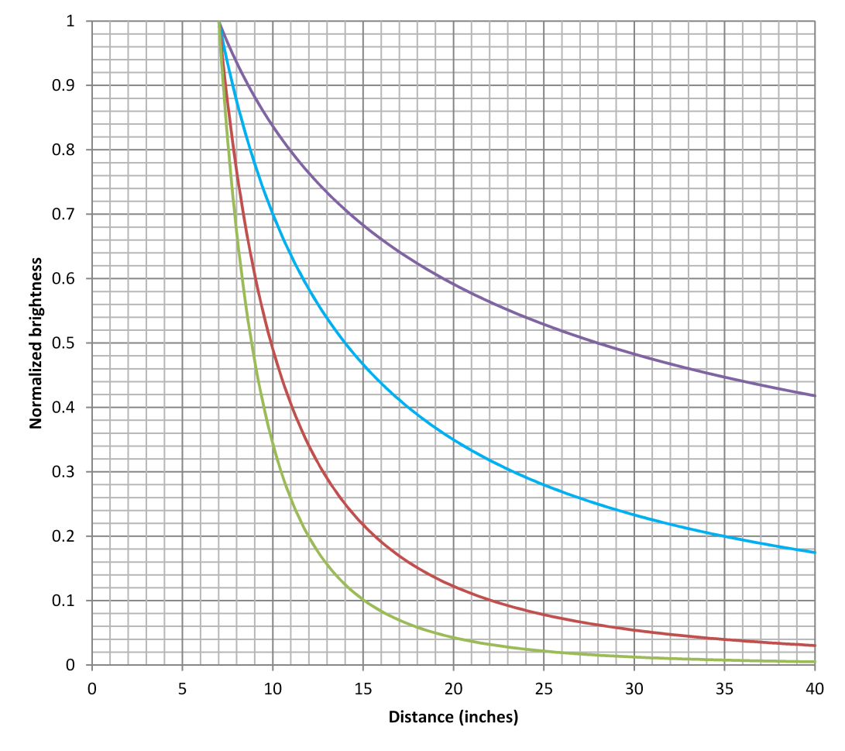
Aside from the data points you’ve added, this graph has four curves – each representing a different possible description of how quickly a light source gets fainter as it moves farther away. All four are relative to the brightness at 7 inches.
The highest curve (in purple) is what the data would look like if the brightness dimmed proportionally to the square root of the distance. (Move the light four times farther away, and it appears 1/2 as bright.)
The second curve (light blue) is what the data would look like if the brightness dimmed proportionally to the distance. (Move the light four times farther away, and it appears 1/4 as bright.)
The third curve (red) is what the data would look like if the brightness dimmed proportionally to the distance squared. (Move the light four times farther away, and it appears 1/16 as bright.)
The lowest curve (light green) is what the data would look like if the brightness dimmed proportionally to the distance cubed. (Move the light four times farther away, and it appears 1/64 as bright.)
Which of the provided relationships best matches our data? [1 point]
- The first curve best matches our data. It shows that the brightness dimmed proportionally to the square root of distance.
Using complete sentences, describe two possibilities that could explain why the data aren’t a perfect match for the ideal model. [2 points]
- The light from the source is not travelling through a vacuum and therefore could be obstructed by parameters such as atmospheric visibility.
- Also, the condition of light movement from a star may be different owing to the fact that the atmospheres are different and have different compositions.

Part 3: Trying It Out (15 points)
If we’re comparing a setup with the known intensity for a given light source at a reference distance, then the relationship looks like this:
$$I_{1}×{d_{1}}^{(?)}= I_{2}×{d_{2}}^{(?)}$$
…where I₂ and d₂ are the intensity and distance you’re looking at, I₁ and d₁ are the reference intensity and distance, and the (?) is the power we figured out from the graphing. (For example, if the intensity goes down like the distance to the third power, then the d’s would be raised to the third power.)
If we’re interested in the light intensity relative to the reference value – for example, if we’re interested in the Sun’s brightness at other planets compared to how it looks from Earth – then we can rearrange things like this:
$$\frac{I_{2}}{I_{1}}= {\left(\frac{d_{1}}{d_{2}}\right)}^{(?)}$$
So if we’re interested in the Sun’s brightness from Neptune’s distance compared to at Earth’s distance, then the answer we’re looking for is I_{Neptune}/I_{Earth}, and it is equal to (d_{Earth}/d_{Neptune}) ^{(?)}. Neptune is about 30 AU away from the Sun, and Earth is 1 AU away from the Sun, so the answer would be (1/30) raised to the (?) power. Calculating that lets us say, “From Neptune, the Sun appears _ (1.111 x 10⁻³) ___ times as bright as seen from Earth.”
Go ahead and calculate that out – how bright is the Sun, as seen from Neptune (compared to what Earth sees)? Give your answer in a complete sentence. [1 point]
- The sun is 1.111 x 10⁻³ times bright as seen from Neptune compare to what Earth sees.
Let’s try it for a few other places.
Compared to how bright the Sun is as seen from Earth, how bright is the Sun as seen from Mars? (Mars is 1.52 AU from the Sun.) [1 point]
(1/1.52)² = 0. 4328
- The sun is 0.4328 times bright as seen from Neptune compare to what Earth sees.
Compared to how bright the Sun is as seen from Earth, how bright is the Sun as seen from Mercury? (Mercury is 0.39 AU from the Sun.) [1 point]
(1/0.39)² = 6.57
- The sun is 6.57 times bright as seen from Mercury compare to what Earth sees.
Compared to how bright the Sun is as seen from Earth, how bright is it at Pluto? (Pluto is 39.5 AU from the Sun on average.) [1 point]
(1/39.5)² = 6.409 x 10⁻⁴
- The sun is 6.409 x 10⁻⁴ times bright as seen from Mercury compare to what Earth sees.
Quick “sanity check”: If a planet is closer to the Sun, the Sun should appear brighter there, and if a planet is farther away, the Sun should appear fainter. Do your answers above agree with that?
Yes
…and of course, this works with other light sources too.
Let’s say you’re camping in the wilderness with a group of friends. You’re enjoying a campfire, but you feel it’s a little too bright – you want your eyes to dark-adjust a little more to see the stars better.
You’re currently seated 10 feet away from the campfire. If you move back to a distance of 25 feet, how bright will the campfire look compared to before? [1 point]
- The campfire would appear dimmer
- The reference point is 10 feet and the distance are 25 feet
- 10/25)² = 0.16
- The campfire will be 0.16 times bright as seen from 25 feet compared to the 10 feet reference point.
In the above calculations, we looked at a desired distance, and calculated the expected brightness of the Sun (or another bright object). We can arrange the relationship a different way, and find the distance at which you’ll experience a desired brightness:
$$\frac{d_{2}}{d_{1}}={\left(\frac{I_{1}}{I_{2}}\right)}^{1/(?)}$$
Here the answer we’re looking for is d₂/d₁, the new distance compared to the original distance. If we’re comparing to Earth, then that could be thought of as a distance in AU. If it’s something else, like your distance from a campfire, it’ll still be compared to that original distance – for example, “2.3 times as far away” rather than a particular number of feet. (If you do want an answer in feet, simply multiply by your original distance in feet.)
That answer is equal to the original intensity divided by the desired intensity, raised to the power of 1/(2).
Let’s say you’re curious about where in the Solar System the Sun would look 75% as bright as at Earth. That fraction becomes (1/0.75), and it gets raised to the power of 1/(2).
Go ahead and calculate that out. How far do you have to be from the Sun, in order for it to look 0.75 times as bright as what Earth sees? [1 point]
= (1/0.75)^{1/2} = $\sqrt{(\frac{1}{.75}}) =$1.155 AU
How far should you be from the Sun for it to look 10% as bright as what Earth sees? [1 point]
= (1/0.10)^{1/2} = $\sqrt{(\frac{1}{.1}}) =$3.162 AU
What if you want the Sun to look a sizzling 100 times as bright as what Earth sees? [1 point]
= (1/100)^{1/2} = $\sqrt{(\frac{1}{100}}) =$0.1 AU

If you’re interested in checking your above answers, make sure that if the Sun looks fainter, you’re farther away. Not just in terms of being closer or farther away than 1 AU – you can also compare it to your previous answers. For example, does the Sun look brighter or fainter than “0.75 times what Earth sees” at Mars? How does your answer compare to Mars’s distance?
The sun looks fainter because Mars is further from the sun than Earth
Let’s venture outside of the Solar System. As astronomers discover planets orbiting around other stars, an important concept to consider is each star’s habitable zone – the region around the star where you’d expect a planet to have Earth-like temperatures, in particular temperatures that would allow liquid water. If a planet is too close to its star, any water would turn to vapor. Too far away, and the planet gets so little energy that any water would freeze. The Sun’s habitable zone is centered around a distance of 1 AU.
Let’s think about the habitable zones for other stars.
The star Vega gives off 40 times as much total light as the Sun. Would Vega’s habitable zone be closer in than 1 AU, or farther away than 1 AU? (You shouldn’t need a calculator yet.) [1 point]
It will be habitable farther than 1AU.
Let’s figure out where Vega’s habitable zone would be. We’ll imagine starting at 1 AU, and traveling to a distance where the star is 1/40 as bright as we’d see at 1 AU. In other words, d₁ = 1 AU, and (I₂/I₁) is 1/40. Use those values (perhaps flipping a fraction) in the above formula to figure out the distance from Vega at which a planet would get Earth-like amounts of light. [1 point]
(40/1)^{1/2} = $\sqrt{(\frac{40}{1})}$ = 6.32 AU
You might remember the monstrous star Deneb from the nighttime observing and from the Scale Models lab. Deneb gives off about 200,000 times as much energy as the Sun. How far away from Deneb would its habitable zone be? [1 point]
(200,000/1)^{1/2} = $\sqrt{(\frac{40}{1})}$ = 447.21 AU
The closest star to the Solar System, Proxima Centauri, is a small dim star that gives off only 0.0017 times as much light as the Sun. How close would a planet have to be to Proxima Centauri to get the same amount of energy that Earth does from the Sun? [1 point]
(0.0017/1)^{1/2} = $\sqrt{(\frac{0.0017}{1})}$ = 0.0412 AU
Astronomers have discovered two planets around Proxima Centauri (though there may be others that haven’t been discovered yet). The planet Proxima Centauri b (discovered in 2013) is located about 0.0486 AU away from its sun, and the planet Proxima Centauri c (discovered in 2019) is about 1.49 AU away from its sun. Based on the amount of light they get; would you expect these planets to be warmer than Earth or cooler than Earth? Explain your answer. [3 points]
Both Planets are further than Proxima Centauri which needs to be 0.0412 AU from the sun to have the same amount of energy as Earth. Therefore, the two planets will be cooler than Earth.

Part 4: Wrap-Up Questions (6 points)
If we see three stars in the night sky that look to be the same brightness, does that mean they are all about the same distance away from us? Why or why not? [2 points]
If they have the same brightness, then they should have the same distance away from us. However, judgement of distance as objects get farther away from us becomes blurred and erratic and therefore the three stars may not be the same distance away from us.
A table showing the distances of the planets from the Sun is below. If you had the ability to move any planet 0.1 AU closer to the Sun – for example, moving Venus to 0.62 AU or moving Jupiter to 5.1 AU – which planet would see the largest change in the amount of sunlight it gets? Explain your answer. [2 points]
Planet | Mercury | Venus | Earth | Mars | Jupiter | Saturn | Uranus | Neptune
Dist. (AU) | 0.39 | 0.72 | 1.00 | 1.52 | 5.2 | 9.6 | 19.2 | 30.1

It will be mercury. Because a change by 0.1 is significant when compared to its distance from the sun.
Your friend is figuring out where to put some solar panels for a building: either on the roof of the building itself, or on the roof of a nearby covered parking lot. Putting the panels on top of the building will be more expensive, but your friend says they’ll collect more energy because they’ll be about 60 feet closer to the Sun. Would it be better to put the panels on top of the building? Explain your answer. (Ignore other issues like shadows.) [2 points]
Yes, it would be better to put the panels on top of the building because it makes it closer to the energy source. As a result, it will gather more energy compared to the one on the parking lot which is further from the sun.

